Course _______Specialist______ Year __12_____

Student name: ________________ Teacher name: ________________

Date: 24 Feb

Task type: Response

Time allowed for this task: _____45______ mins

Number of questions: _____8______

Materials required: Calculator with CAS capability (to be provided by the student)

Standard items: Pens (blue/black preferred), pencils (including coloured), sharpener, correction fluid/tape, eraser, ruler, highlighters

Special items: Drawing instruments, templates, notes on one unfolded sheet of
A4 paper, and up to three calculators approved for use in the WACE examinations

Marks available: __50____ marks

Task weighting: _10___%

Formula sheet provided: Yes

Note: All part questions worth more than 2 marks require working to obtain full marks.

Q1 (3.1.1, 3.1.2, 3.1.3) (2, 2, 3 & 3 = 10 marks)
If and determine exactly the following. (Simplify)

Q2 (3.1.3) (3 marks)
Determine all possible real values of such that

Q3 (3.1.14, 3.1.15) (3& 3 = 6 marks)
Consider the quadratic equation where are real.
- If one root of the above equation is , determine .

Consider the equation where are real.

- If the cubic equation above has roots , determine .

Q4 (3.1.3, 3.1.3, 3.1.3) (2 marks)
Determine in the form with . (Note: diagram not drawn to scale)

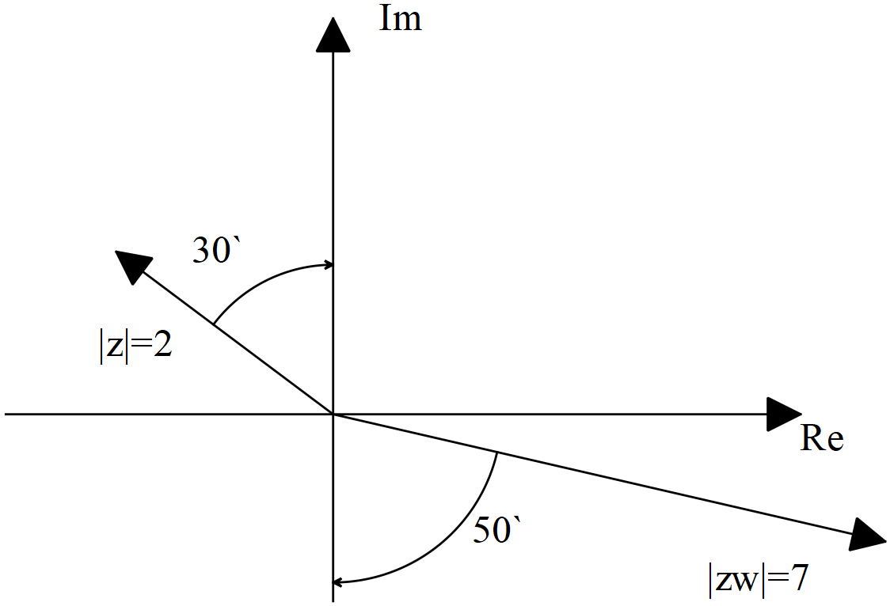

Q5 (3.1.10) (2, 2 & 3 = 7 marks)
Sketch the following regions in the complex plane showing major features.
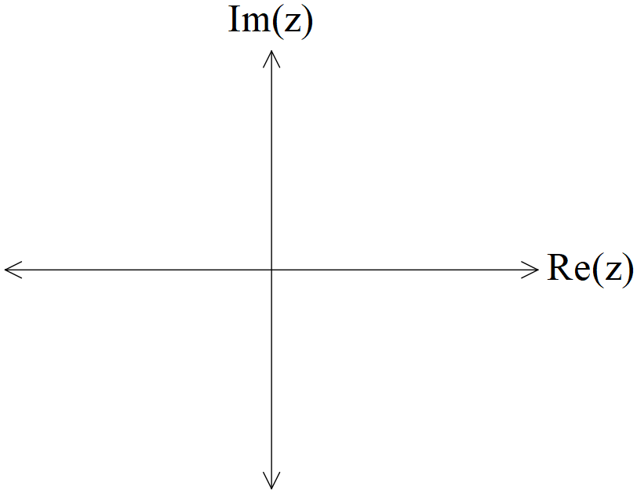

- Consider all the complex numbers that satisfy , determine the maximum possible value of , giving your answer in radians correct to two decimal places.

Q6 (3.1.7, 3.1.12) (4 & 3=7 marks)
- Determine all the roots of expressing in the form with .

- Plot all of these roots on the diagram below.

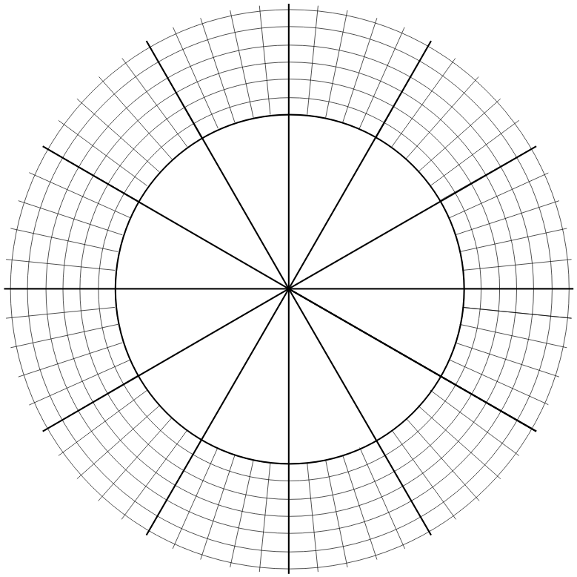

Q7 (3.2.1, 3.2.2) (1, 2, 2 & 2 = 7 marks)
Consider the functions .
- Give the defining rule for .

- Does exist over the natural domain of ? Explain

- State the natural domain and range for .

Consider the function .
- Does the function ? Justify your answer.

Q8 (3.2.3, 3.2.4) (2 , 3 & 3 = 8 marks)
Consider the function drawn below.
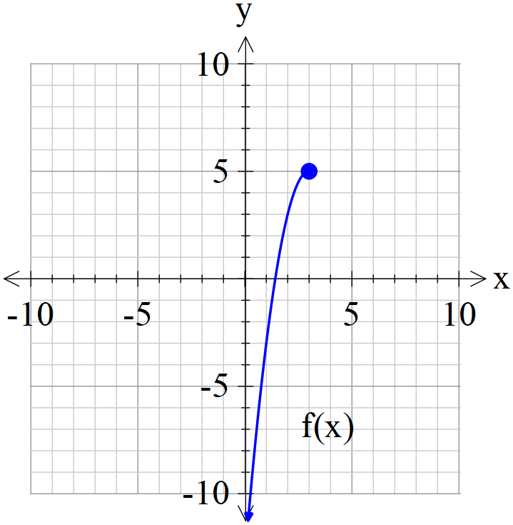

- Sketch on the axes above.

- Given that , determine the defining rule for .
Show working for full marks.

- Consider the function where is a positive constant. Solve in terms of , the solution(s) to .

Working out space

